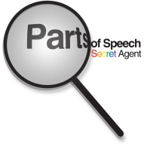

Go Back Definitions
Level I
Parts of Speech

It is essential to memorize the major definitions in grammar. Go Back is a memorization game; the teacher asks students definitions, and when someone misses one, you have to go back to the beginning! For purposes of consistency when playing GoBack, you can use these definitions for some of the major terms in the parts of speech.

Grammar: a way of thinking about language
Four levels of traditional grammar: parts of speech, parts of sentence, phrases, clauses
Parts of speech: the eight kinds of words in English
Noun: the name of a person, place, or thing
Pronoun: a word that takes the place of a noun
Subject pronouns: pronouns used for subjects of verbs and subject complements
List the subject pronouns: I, you, he, she, it, we, they
Object pronouns: pronouns used as a direct or indirect objects, and objects of prepositions
List the object pronouns: me, you, him, her, it, us, them
Adjective: a word that modifies a noun or pronoun NOTE: Article: the three adjectives, a, an, and the
Verb: a word that shows action, being, or links a subject to its subject complement
Adverb: modifies verbs, adjectives, and other adverbs
Conjunction: a word that joins two words or two groups of words
List all the coordinating conjunctions: and, but, or, nor, for, so, yet (FANBOYS)
List a few subordinating conjunctions: if, as, since, when, because
The correlative conjunctions: either or, neither nor, not only but also
Preposition: shows the relationship between its object and another word in the sentence
Interjection: shows emotion but has no grammatical function

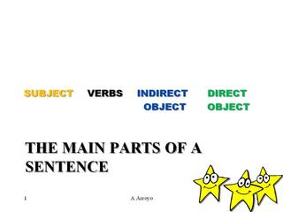

Go Back Definitions
Level II
Parts of Sentence

For purposes of consistency when playing Go Back, you can use these definitions for some of the major terms in the parts of sentence. Be sure to review the Go Back definitions from the Parts of Speech, because the game will be cumulative.

Sentence: a group of words that has a subject and its predicate, and makes a complete thought
Fragment: an incomplete thought
Subject: the noun or subject pronoun that the sentence is about
Predicate: the simple predicate is the verb—it is either action or linking (AVP or LVP)
Direct object: the noun or object pronoun that receives the action of the action verb

Indirect object: the noun or object pronoun between the action verb and the direct object, that is indirectly affected by the action

Subject complement: the noun, subject pronoun, or adjective, that is linked to the subject by a linking verb, and tells more about the subject

*When you have a LVP, look for a subject complement

*When you have an AVP, look for a direct object and then an indirect object

